**NAME: ……………………………………………………… RANDOM NO. ……………**

**CANDIDATE NO. ………………………………………….**

**UCE MOCK**

**BIOLOGY**

**THEORY**

**553/1**

**2 ½ HOURS**

**UGANDA CERTIFICATE OF EDUCATION**

**MOCK EXAMINATION**

**BIOLOGY PAPER 1**

**(THEORY)**

**553/1**

**TIME: 2 HOURS 30 MINUTES**

**INSTRUCTIONS**

* *Answer all questions in section A and B*
* *Write the answers to section A in the boxes in the margin of each question*
* *Write answers to section B in the spaces provided*
* *Answer only two questions from section C*
* *Write the answers to section C on the answer sheets provided.*

**FOR EXAMINERS USE ONLY**

|  |  |
| --- | --- |
| **SECTION** | **MARKS** |
| A |  |
| B 31 |  |
| B 32 |  |
| B 33 |  |
| C |  |
| C |  |
| **TOTAL** |  |

1. The commonest pioneer species during ecological succession are
   1. Lichens
   2. Mosses
   3. Ferns
   4. Forests
2. One major characteristic feature present in mesophyll cells but lacking in other plant cells is
   1. Sap vacuole
   2. Chloroplasts
   3. Mitochondria
   4. Cell walls
3. One major disadvantage of an exoskeleton is that it is
   1. Impermeable to water
   2. Impermeable to oxygen
   3. Rigid, hindering movement
   4. Rigid, hindering growth
4. When amoeba is placed in a hypertonic solution, formation of contractile vacuoles occurs at a
   1. High rate in order to eliminate excess water
   2. High rate in order to eliminate excess salts
   3. Slow rate because there is little water
   4. Slow rate because there is little salt
5. The tape-like structure of a tapeworm is for increasing
   1. Camouflage
   2. Rate of reproduction
   3. Diffusion rate
   4. Protection from the hosts enzymes
6. Brightly coloured large petals in flowers increases the following chances except
   1. Self pollination
   2. Insect pollination
   3. Cross pollination
   4. Variability
7. Which one of the following may not be considered as a contraceptive method?
   1. Rhythm method
   2. Abstinence method
   3. Tubal ligation
   4. Coitus interuptus
8. One advantage of complete metamorphosis over incomplete metamorphosis in insects is that complete metamorphosis
   1. Occurs faster
   2. Occurs slowly
   3. Involves 4 stages
   4. Reduces competition
9. The figure below shows part of the skin and scales on a fish. The most probable position of the head to the fish is in direction:

A

B

D

C

1. Which one of the following is the major factor in leaching soil?
   1. Large number of micro organisms
   2. High nutrient content
   3. Large number of macro organisms
   4. High rainfall

Number of individuals

Character

The following characters may give rise to the curve above except

* 1. Height in humans
  2. Weight in cattle
  3. Skin colour in humans
  4. Blood groups in humans

1. Genes on the same chromosome are usually inherited together because they are
   1. Dominant
   2. Linked
   3. Recessive
   4. Co-dominant
2. Amino acids are to proteins as ………………… are to starch
   1. Glucose molecules
   2. Fatty acid molecules
   3. Glycerol molecules
   4. Maltose molecules
3. Which combination of the following factors will lead to high transpiration rate?

|  |  |
| --- | --- |
| 1. High temperature 2. High humidity 3. High atmospheric pressure 4. High wind velocity | 1. Low temperature 2. Low humidity 3. Low atmospheric pressure 4. Low wind velocity |

* 1. i, ii, iii, iv
  2. v, vi, vii, viii
  3. i, ii, iii, iv
  4. i, iv, vi, vii

1. Agglutination of blood is most likely to occur when the respective donor and recipient are of blood group
   1. A and AB
   2. B and AB
   3. O and AB
   4. AB and O
2. The major advantage of narrow lumen of arteries is
   1. Fast delivery of metabolites to far organs
   2. Reduced blood pressure
   3. Protection from bursting
   4. Fast return of blood to the heart
3. The enzyme property under investigation in the figure below is that enzymes are

Water

Irish cubes

Hydrogen peroxide

Gas bubbles

* 1. Protein in nature
  2. Specific
  3. Affected by pH
  4. Denatured by heat

1. When Mimosa pudica is touched, its leaves fold, this response belongs to same group as
   1. Growth of plant shoots towards light
   2. Opening of flowers of some plants in the morning
   3. Euglena swimming towards light
   4. Plant shoot growth away from the pull of gravity
2. Which one of the following is a major reason for lack of special excretory organs in plants?
   1. Plants do not excrete
   2. Plants do not use proteins
   3. Plants deposit some excretory products in organs which are later shed off
   4. Plants do not take in oxygen during respiration
3. Which one of the following sets of hormonal deficiency lead to excessive loss of water from the body
   1. Insulin and ADH
   2. Oestrogen and Insulin
   3. Thyroxine and ADH
   4. Oxytocin and insulin
4. Fusion of some bones in birds skeletons is for
   1. Reduction in weight
   2. Streamlining the body
   3. Formation of a rigid framework
   4. Increasing surface area
5. Which one of the following would increase the “green house effect”?
   1. Planting more trees
   2. Using solar energy instead of fossil fuels
   3. Building more industries which use petroleum
   4. Increased use of hydro-electric power, HEP
6. The stage in cell division where synthesis of protoplasm and replication of genetic material is
   1. Prophase
   2. Interphase
   3. Metaphase
   4. Telopahse
7. Insects are one of the most successful classes of animals because of the following except
   1. They lay very many eggs
   2. Short life cycle
   3. Many mouth modifications
   4. Intermittent growth
8. Which one of the following pairs constitutes homologous organs
   1. Wings of a bat and those of insects
   2. Flippers of whales and wings of a bird
   3. Hands of humans and wings of insects
   4. Wings of insects and fins of a fish
9. The figure below shows the scolex of a tapeworm. The part labeled X is used for

X

* 1. Sight
  2. Feeding
  3. Excretion
  4. Anchorage

1. Products of digestion absorbed into the lacteals are transported by the
   1. Blood capillaries
   2. Lymphatic vessels
   3. Veins
   4. Arteries
2. The figure below shows an inverted pyramid

C

B

A

Which one of the sets below shows the correct organisms at trophic levels A, B and C in their respective order?

* 1. Tree, Birds, Mites
  2. Grass, Cattle, Ticks
  3. Grass, Antelopes, Lions
  4. Trees, Termites, lizards

1. The figure below shows a Bidens fruit

Q

Part labeled Q is formed from

* 1. Corolla
  2. Calyx
  3. Style
  4. Filaments

1. A small body needs more covering on a cold day than a bid adult because the small body has a
   1. Delicious skin
   2. Small surface area to volume ratio
   3. Large surface area to volume ratio
   4. Low metabolic rate

**SECTION B**

1. An investigation was carried out into the concentration of lactic acid in the blood of a man before, during and after a vigorous exercise. The results are summarized below.

|  |  |
| --- | --- |
| **Time (minutes)** | **Concentration of lactic acid (mg/100cm3)** |
| -10 | 9 |
| 0 | 14 |
| 10 | 80 |
| 15 | 95 |
| 20 | 70 |
| 40 | 35 |
| 60 | 22 |
| 80 | 18 |

1. Represent the above information on a suitable graph.
2. Where in the human body is lactic acid produced during the exercise?

1. i) Describe the graph obtained.

ii) Give reasons for the observed changes in concentration of lactic acid in blood.

1. In an experiment, a measuring cylinder was filled with water and then inverted over a delivery tube. 200cm3 of exhaled air was bubbled into the measuring cylinder. A piece of phosphorus born on a wire was pushed into the exhaled air in the cylinder. After phosphorous stopping to burn, the volume air was 168cm3.

Remaining air 168cm3

Measuring Cylinder

Exhaled air 200cm3

Final water level

Burning phosphorous in exhaled air

Original water level

Mouth

Iron wire

Water

1. State the aim of the above experiment

1. i) Calculate the percentage decrease in volume of air after the burning of phosphorus.

1. Explain why the volume of air decreases at the end of the experiment.

1. What volume of air would remain if the same volume of atmospheric air was used instead of exhaled air?

1. The diagram below shows part of the human nephron

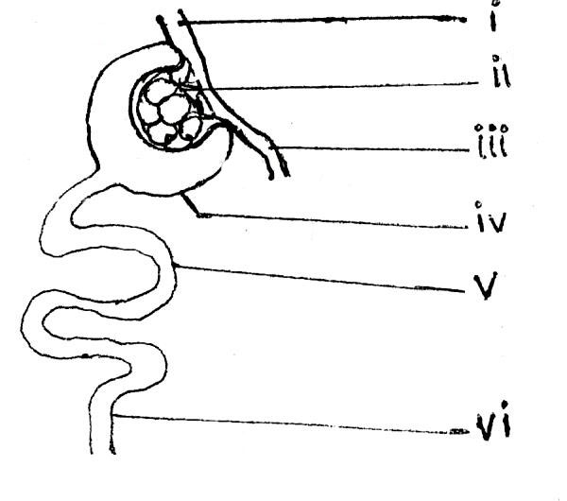

1. Name the labeled parts

i iv)

ii v)

iii vi)

1. Explain how part (ii) is adapted for its functions

1. What is the importance of the diameter of vessels (i) and (iii)?

1. State the importance of the process which occurs in part(v)

**SECTION C**

***Answer two questions***

1. In which ways is water important to living organisms?
2. a) State the importance of bones in a human body

b) State the difference between an exoskeleton and Endoskeleton

c) Describe the process leading to bending of a human arm.

1. a) Explain how plants adapt for
2. Gross pollination
3. Wind pollination
4. Insect pollination

b) State the differences between the processes leading to fertilization in flowers and humans

1. A cross between Red and White flowered snap dragon plants produces F1 with Pink flowers
2. Explain the absence of white and red flowered plants in the F1. Fully show your working.
3. Calculate the genotypic and phenotypic ratios of a cross between F1 plant and a white flowered plant

***\*\*END\*\****